Created s3 bucket and uploaded a file.
Created ec2 instance
Created IAM role with AWS account trusted entity type and entered another account ID
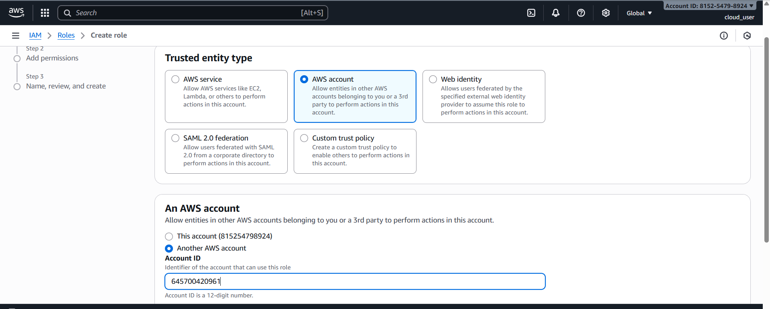

Attached ec2 and s3 full access permission to role

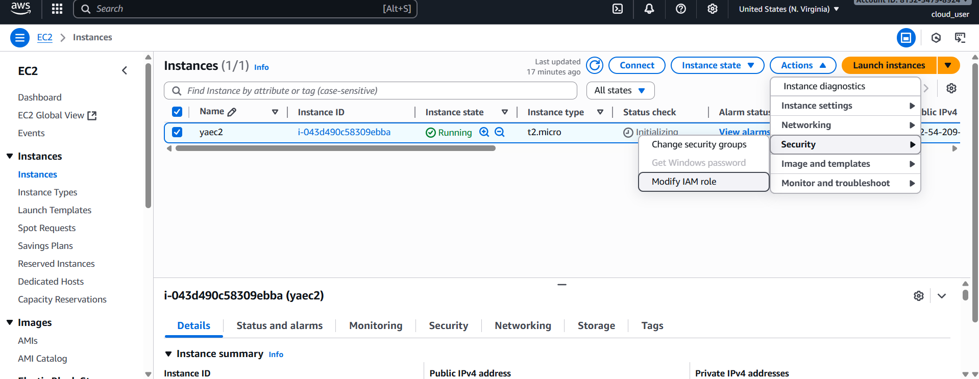

Creating service role
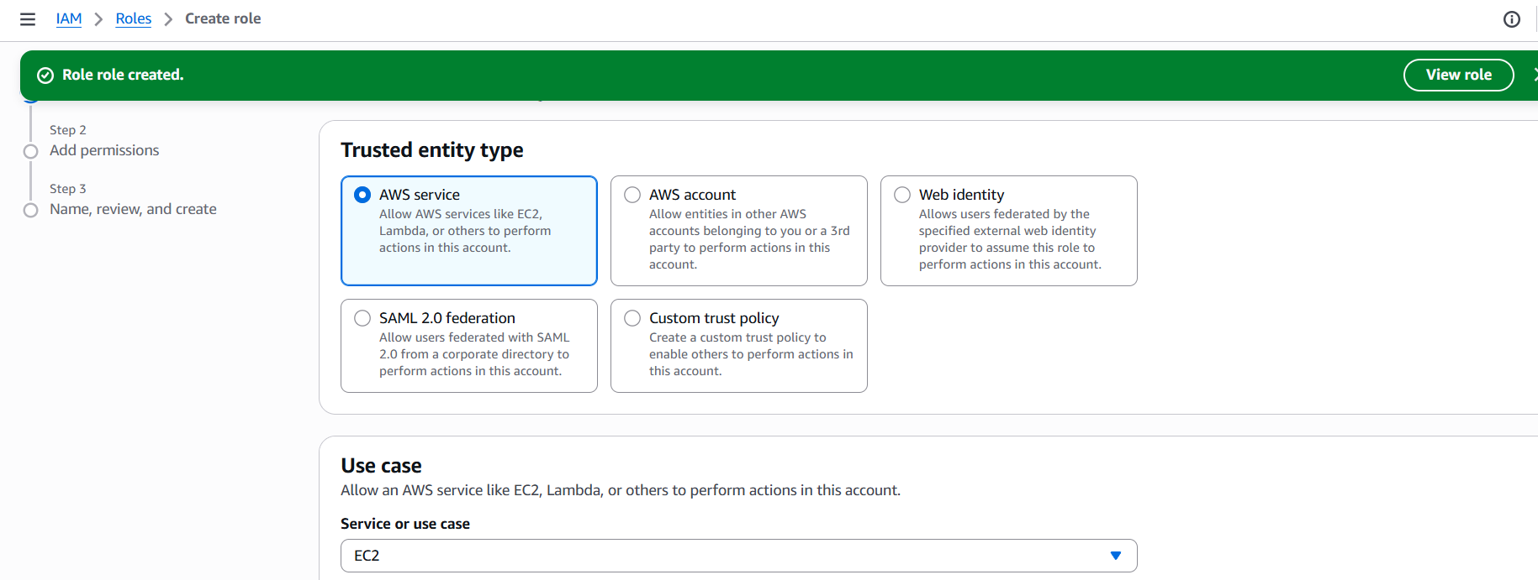

Added s3 access to ec2
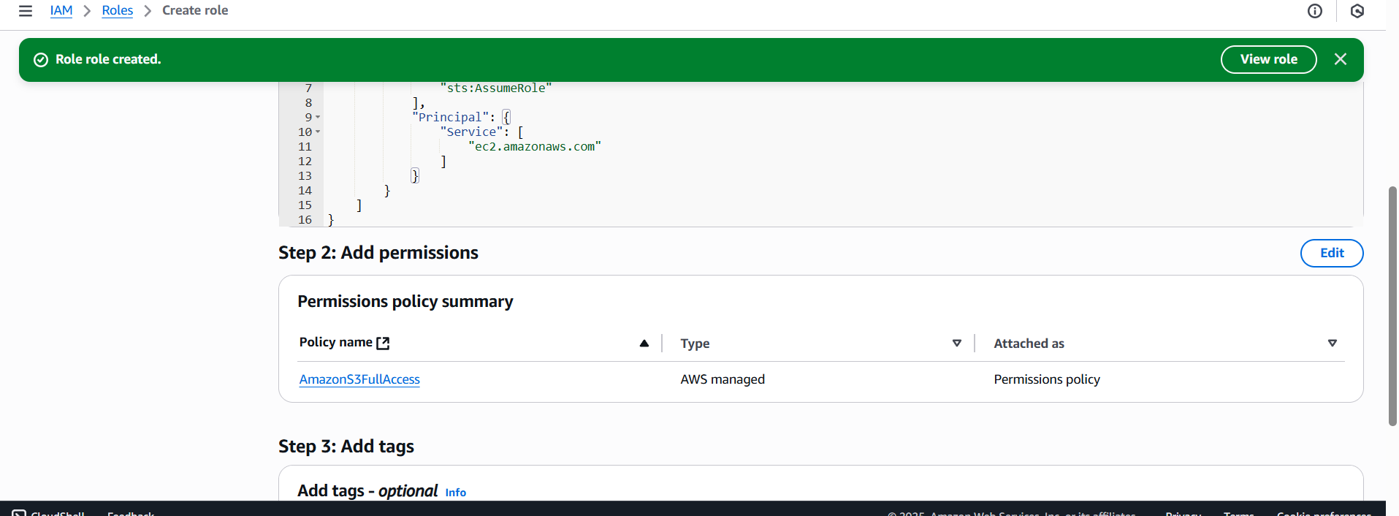
Attaching role to ec2
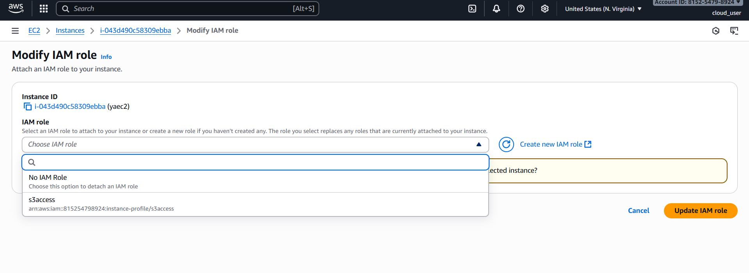
Root user access
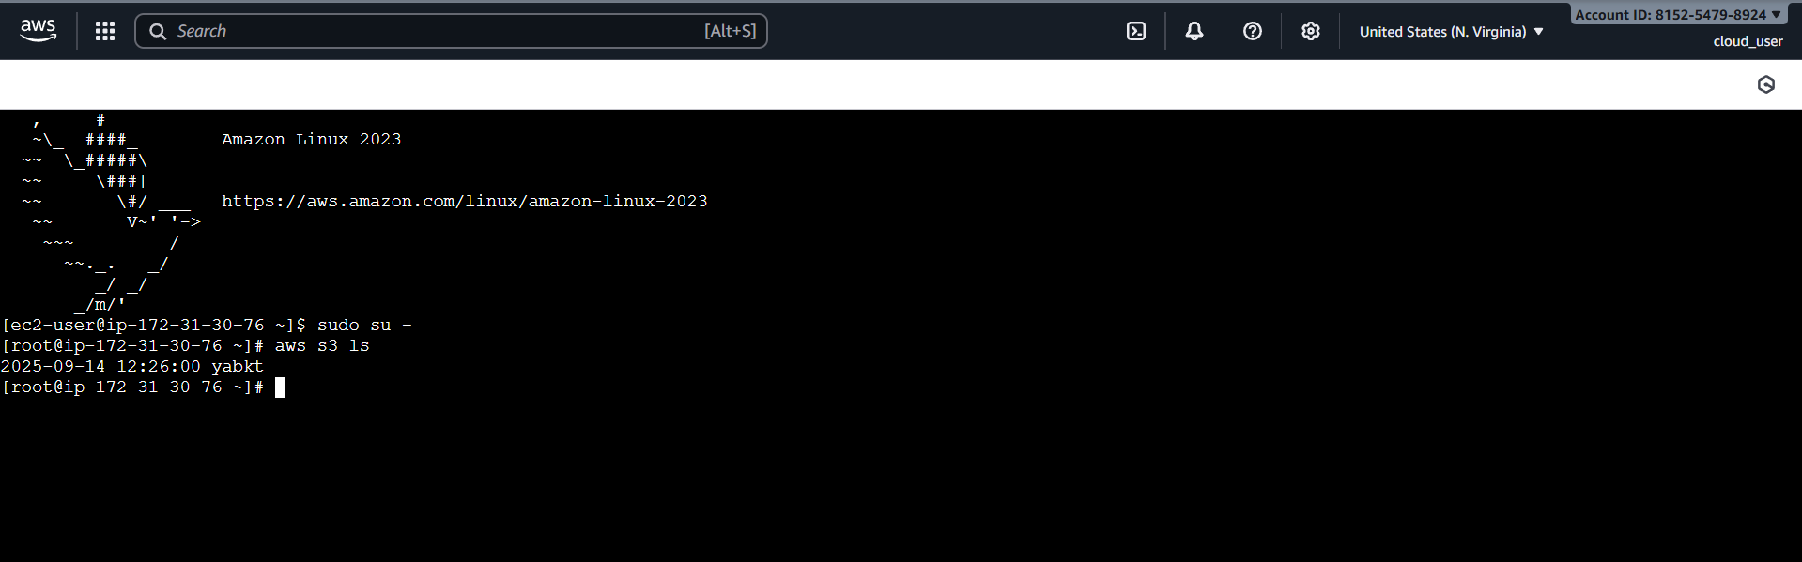

Account B
Iam user is created with admin access
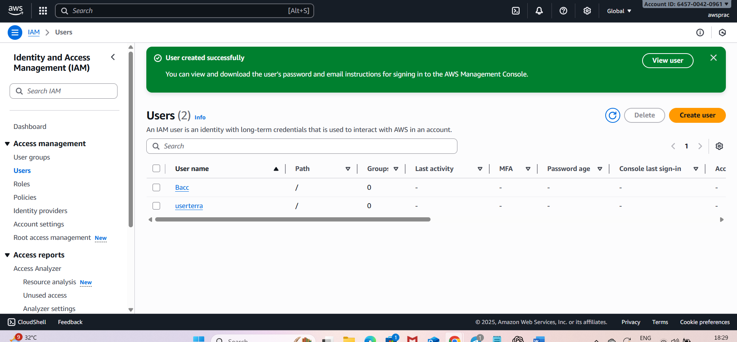
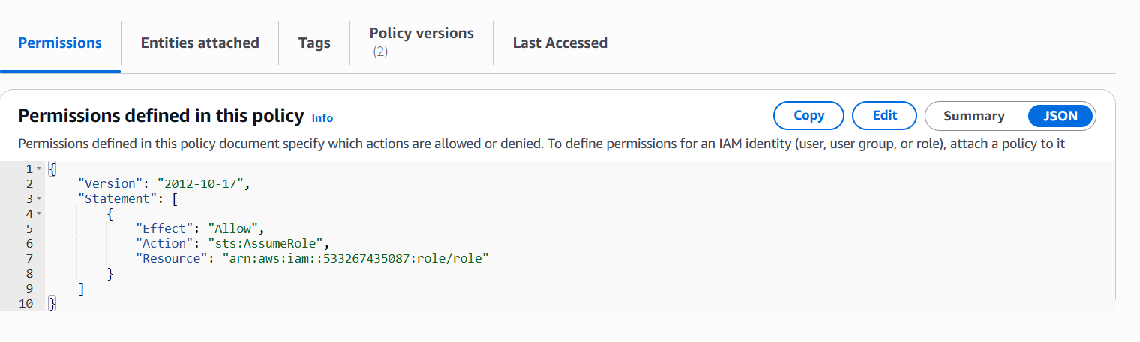
Creating credentials for accb iam user
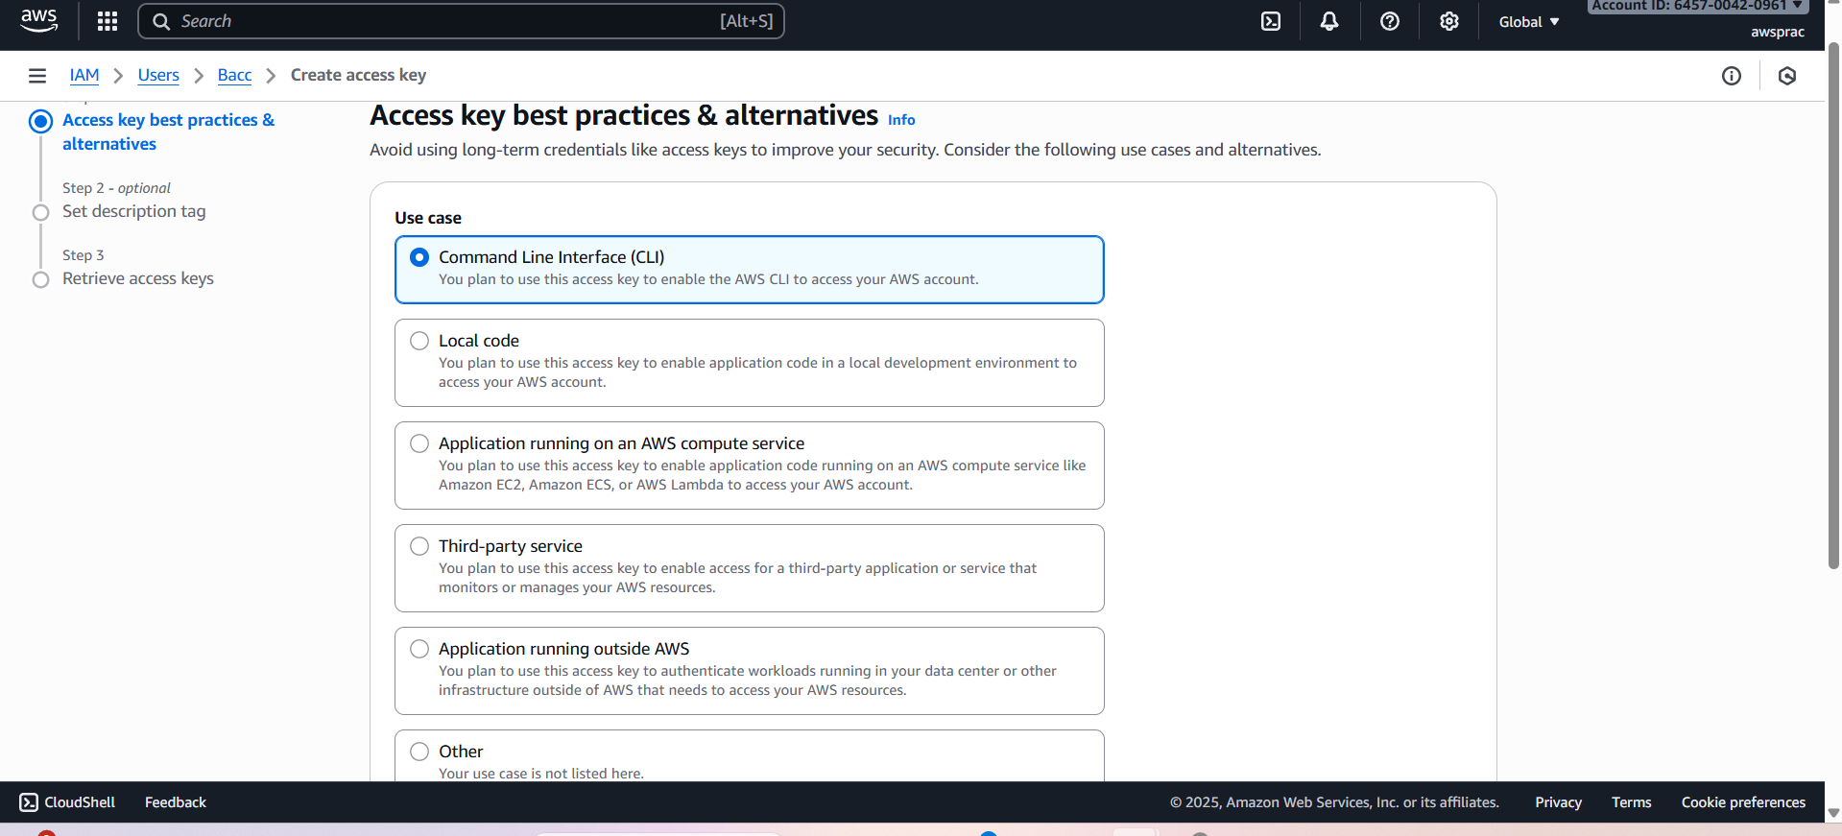
Signin IAM user with created credentials
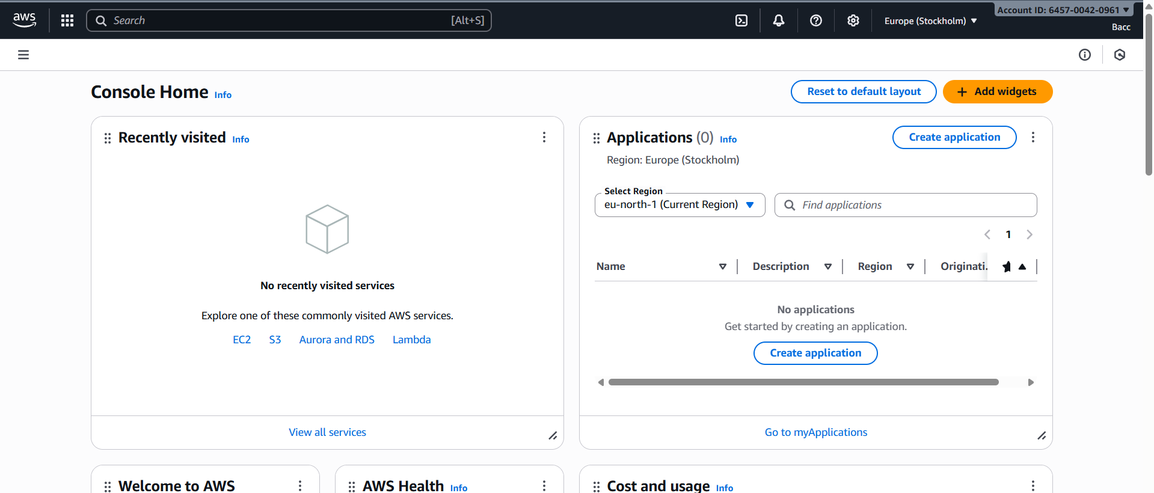
Switch role
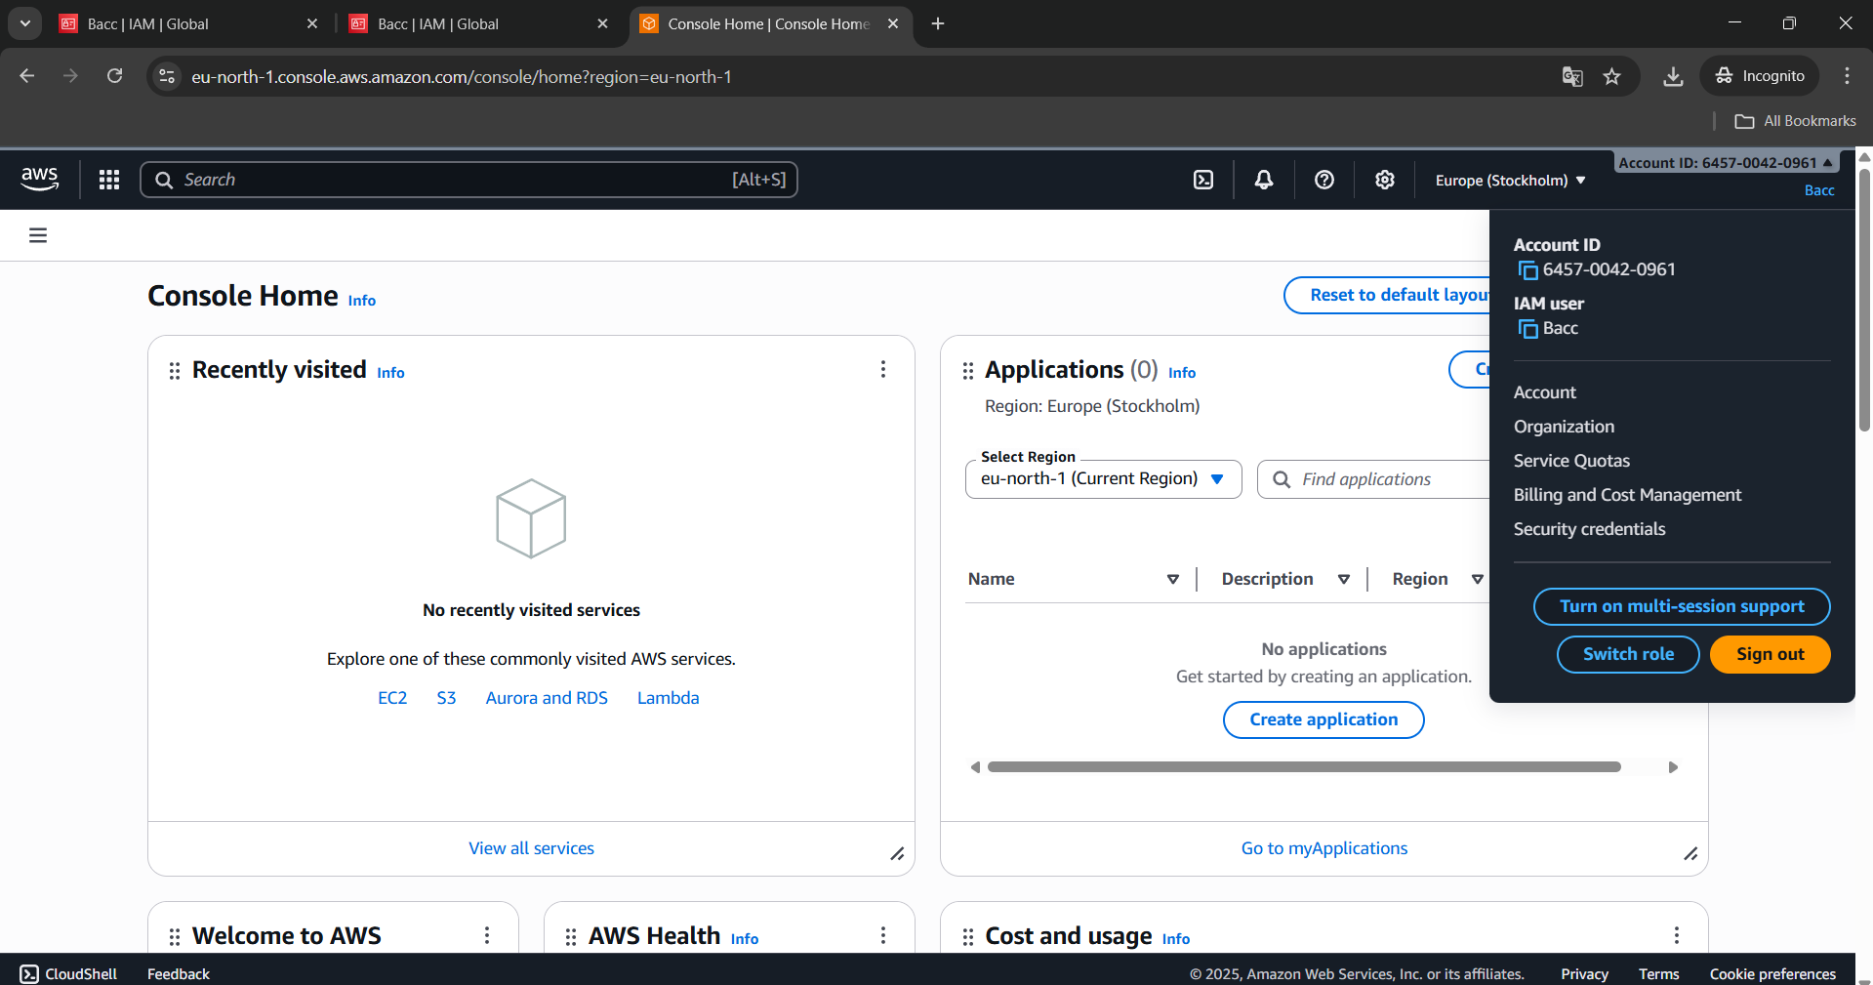
Switch role Account detail (account A with created role name-role)
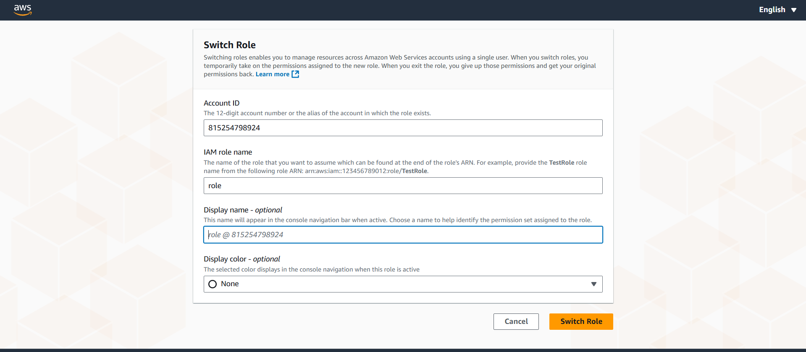

After ACC-B IAM user switched role able to access ACC-A instance
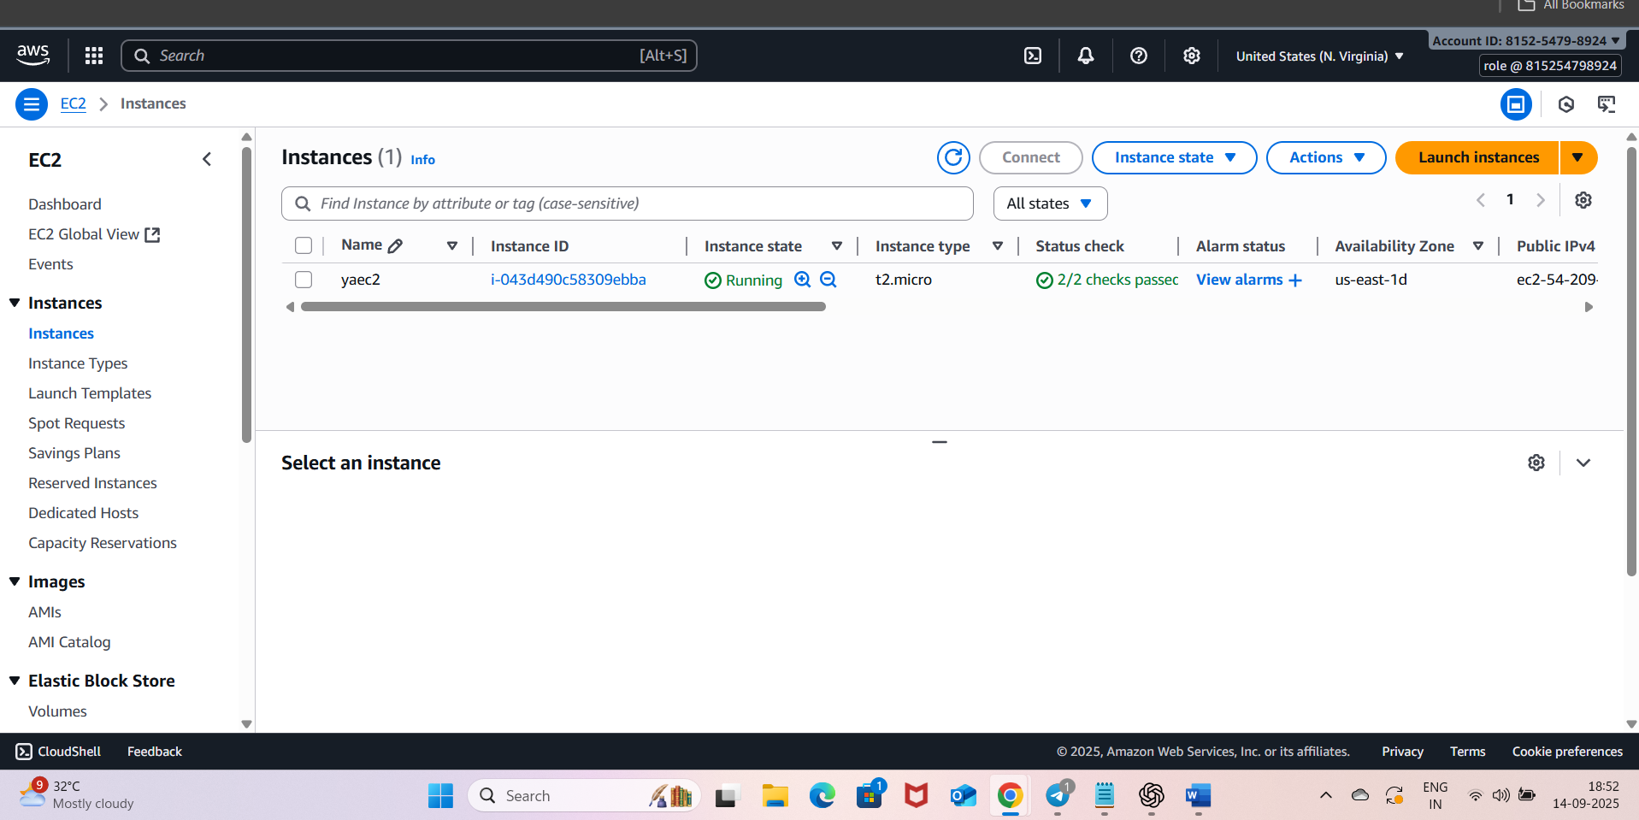
We can see signed in as Bacc(iam username with account id of acc-b) and switched role (role-rolename in acc id of acc-a)
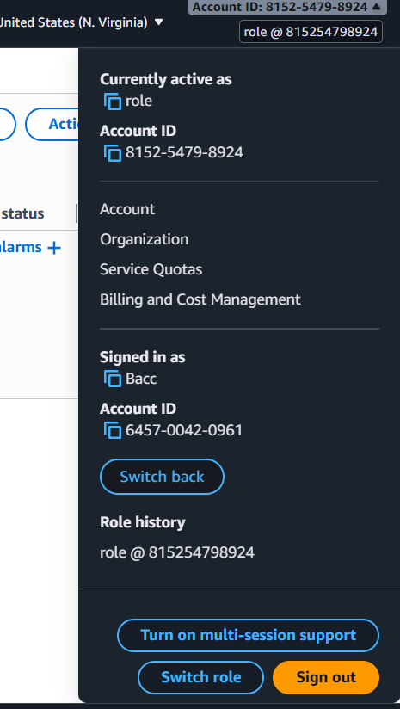
Able to connect server and access s3 bucket list from iam user switched role to acc-a
